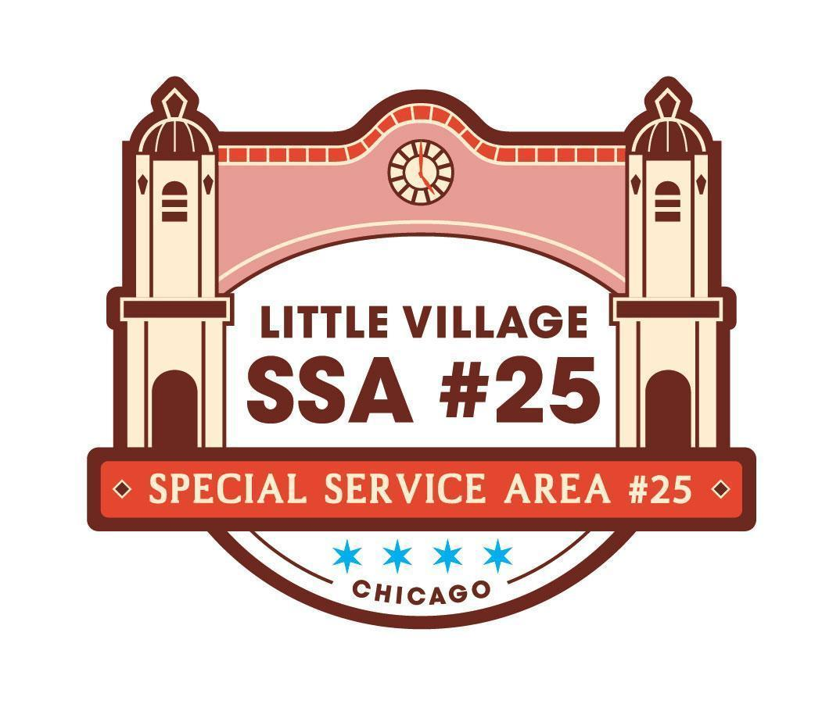

SSA #25 Special Commission Meeting
September 22, 2026
LV Chamber of Commerce Office, 3610 W 26th ST
Chicago, IL 60623
AGENDA

9:00AM
- Welcome and Call Meeting to Order
- SSA #25 Commissioner Roll Call
- Approval of Agenda
- Public Input (review guidelines for public input below)
- SSA #25 August 2026 Meeting Minutes pg 2- 4
- SSA #25 August 2026 Financial Reports pg 5- 10
- SSA #25 Payment Disbursement pg 11

NEW BUSINESS:
- Letter of Donation - Power Washer pg 12
- Landscape Management ACTION ITEM
  - 2026 Holiday Decor - Manuel Perez Jr Plaza pg 13-15
  - 2026 Business Corridor Holiday Decoration Installation pg 21- 25
  - 2026 Post Office Seasonal Color Installations pg 16-20
- 2026 Trolley ACTION ITEM pg 26-29

OLD BUSINESS:
- Villarte Overview pg 30
- Next Commission Meeting
  - October 20th , 2026
  - Taqueria Los Comales 3141 W 26th Street

Guidelines for Public Input:
• The goal of public input is to ensure that all voices of the community are heard on matters pertaining to the work of Little Village SSA #25. The commission is not required to provide immediate response to questions nor concerns presented.
• Public input will be available at the start of each SSA #25 meeting once SSA #25 Commisisoner roll call has been made
• The opportunity to speak during public input will be available for all those in attendance;
however, speaking time may be limited depending on the number of attendees wishing to speak.
The Commission will aim to limit this portion of the meeting to no more than 15 minutes.
• The public forum portion of SSA #25 commission meetings, as with all portions of the meeting, will proceed according to Robert’s Rules of Order, most importantly:
-No attendee may speak twice until everyone else wishing to speak has spoken once.
-All remarks must be directed to the Chair.
-Remarks must be courteous in language and deportment avoiding all personal remarks and never alluding to others by name or to motives.
-One person may speak at a time, if not the presiding officer can call them out of order

