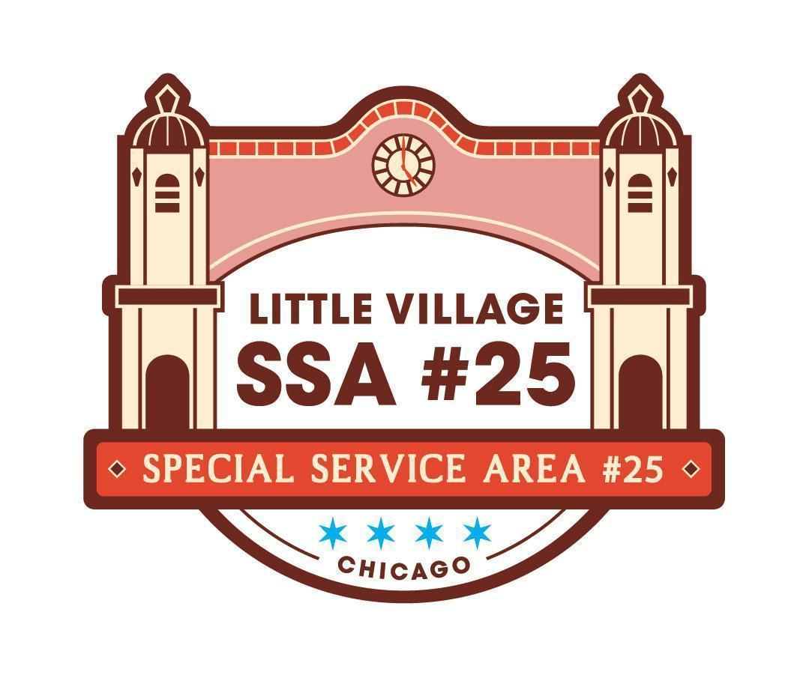

SSA #25 Special Commission Meeting
September 22, 2026
LV Chamber of Commerce Office
3610 W 26th ST
Chicago, IL 60623
MEETING MINUTES

9:10AM
- Welcome and Call Meeting to Order
- SSA #25 Commissioner Roll Call
  - Commissioners: Claudia Rodriguez, Elena Duran, Ric Porrez, Mike Moreno, Hugo Avila
  - Staff: Jennifer Aguliar, Veronica Pena, Paola Rodriguez, Alfredo Palafox
  - Public:
- Approval of Agenda
  - MOTION: Commissioner Moreno moved to approve the agenda. Commissioner Avila second the motion. Motion carried unanimously.
- Public Input (review guidelines for public input below)
  - No public input
- SSA #25 August 2026 Meeting Minutes pg
  - MOTION: Commissioner Avila moved to approve the August 2026 meeting minutes. Commissioner Moreno seconded the motion. Motion carried unanimously
- SSA #25 August 2026 Financial Reports pg 5-10
  - As of August 31, 2026, the total collected property tax revenue is $347,989.18 and from that $128,067.89 is from the collection of the 2024 property taxes, and $219,691.25 is from the 2025 property taxes.
  - As of August 31, 2026, a total of $218,625.58 has been expensed
  - Noting that the largest expense is landscaping at $62,436.25
  - Current cash flow is $321,192.95
  - MOTION: Commissioner Moreno moved to approve the Financial Reports. Commissioner Avila second the motion. Motion carried unanimously.
- SSA #25 Payment Disbursement
  - As of August 31st, we only have one check for August.
  - Check # 2639 is for Landscape Concept Management’s seasonal color rotation in the amount of $12,487.25
  - MOTION: Commissioner Moreno moved to approve the Payment Disbursement. Commissioner Avila second the motion. Motion carried unanimously.
NEW BUSINESS:
- Letter of Donation - Power Washer
  - I have gathered all of the necessary documents to move forward with the donation, and the letter in this packet is also part of the items needed. Please review the letter, and if it seems correct, we can move forward with a signature from the Chairperson, Claudia Rodriguez.
  - Once signed, I will send an email to Mark Roschen that will include:
    - Purchase date- September 2012
    - Purchase price- $12,000
    - Photo of machine
    - Repair estimate- $4,400
    - Request to Dispose demonstrating the service provider is not profiting from the transaction (i.e., gifting to a non-profit organization)
- Landscape Management ACTION ITEM
  - 2026 Holiday Decor - Manuel Perez Jr Plaza
    - MOTION: Commissioner Moreno moved to approve the Holiday Decor. Commissioner Avila seconded the motion. Motion carried unanimously.
  - 2026 Business Corridor Holiday Decoration Installation
    - Both of these items have usually been covered by Choose Chicago’s Holiday fund, and there is a high chance that we don’t receive it this year and I wanted to see if this is something the SSA #25 would like to fund for the 2026 season.
    - We usually don’t hear about the funding until mid or end of November, so if we’d prefer to wait to hear from Choose Chicago, then we can wait, but I wanted to keep this on your radar.
    - MOTION: Commissioner Avila moved to approve the Business Corridor Holiday Decoration Installation. Commissioner Moreno seconded the motion. Motion carried unanimously.
  - 2026 Post Office Seasonal Color Installations ACTION ITEM
    - From our last meeting, there was an inquiry about adding two planters into the Landscape Management Concept service.
    - The quote found in this packet shows the added planters will be $1,038 to have both the fall and winter displays.
    - Line item 2.02 Landscaping does not have enough, but would need to motion to transfer $1,038.00 from line item 2.03 (facade enhancement rebate program) to line item 2.02
    - MOTION: Commissioner Moreno moved to approve the Landscape Management. Commissioner Avila seconded the motion. Motion carried unanimously.
- 2026 Trolley ACTION ITEM
  - For the past three years, we have requested quotes from different Transportation services and have usually found the best price and services with Ponterelli.
  - This year, we reached out to Ponterelli and Aries Charter Transportation, Inc. and only received a quote from Ponterelli
  - We requested a quote for 6 dates, December 5, 6, 12, 13, 19, and 20 for two trolleys and two characters on each trolley; the total came out to $29,694.00
  - We have exactly a total of $30,000 available in line item 4.04 Shuttle Services
  - MOTION: Commissioner Moreno moved to approve the 2026 Trolley. Commissioner Avila second the motion. Motion carried unanimously.

OLD BUSINESS:
- Villarte Overview
  - This year will mark the 20th anniversary of the Villarte event in Little Village
  - It will be held November 1st- November 7th
  - This year, they hope to have a total of 20 or more local businesses and organizations
  - This week-long celebration will highlight local artists, entrepreneurs, businesses, and community organizations.
  - Laura has provided a breakdown of the funding. Sharing that the funds will be used for catering services from FoodHero, and a majority of the funds will be used to cover printing services by Trinum Studi. Both of these businesses are found within the SSA #25 bounds, and this will continue to allow the funds to directly support local businesses.
  - Once the flyers become available, Laura will drop some off at the office.

- Next Commission Meeting
  - October 20th , 2026
  - Taqueria Los Comales 3141 W 26th Street
    - Commission Avila moved to adjourn the meeting at 9:48. Commission Moreno seconded the motion. Motion carried unanimously.

Guidelines for Public Input:
• The goal of public input is to ensure that all voices of the community are heard on matters pertaining to the work of Little Village SSA #25. The commission is not required to provide immediate response to questions nor concerns presented.
• Public input will be available at the start of each SSA #25 meeting once SSA #25 Commisisoner roll call has been made
• The opportunity to speak during public input will be available for all those in attendance;
however, speaking time may be limited depending on the number of attendees wishing to speak.
The Commission will aim to limit this portion of the meeting to no more than 15 minutes.
• The public forum portion of SSA #25 commission meetings, as with all portions of the meeting, will proceed according to Robert’s Rules of Order, most importantly:
-No attendee may speak twice until everyone else wishing to speak has spoken once.
-All remarks must be directed to the Chair.
-Remarks must be courteous in language and deportment avoiding all personal remarks and never alluding to others by name or to motives.
-One person may speak at a time, if not the presiding officer can call them out of order

