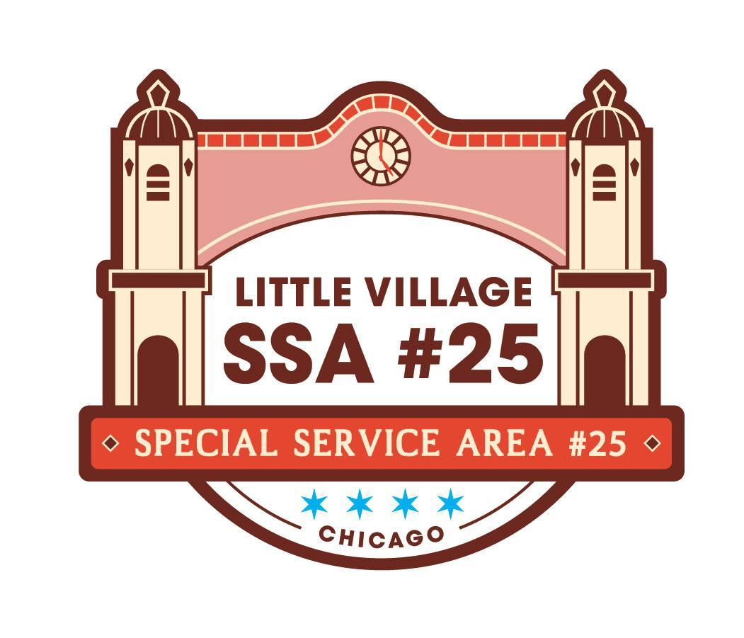

SSA #25 Special Commission Meeting
July 7, 2026
LV Chamber of Commerce Office
Lucidos Tacos, 4147 W 26th Street
AGENDA

9:00AM
- Welcome and Call Meeting to Order
- SSA #25 Commissioner Roll Call
- Approval of Agenda pg 1
- Public Input (review guidelines for public input below)
- SSA #25 May 2026 Meeting Minutes pg 2- 4
- SSA #25 June 2026 Meeting Minutes NO QUORUM pg 5
- SSA #25 June 2026 Financial Reports pg 6- 11
- SSA #25 Payment Disbursement pg 12

NEW BUSINESS:
- SSA #25 Chair position vote
  - Claudia Rodriguez for Chair
- Approval of the 2027 SSA #25 Budget pg 13- 14
  - Approval of 2027 Services
  - Approval of 2027 Budget
  - Approval of 2027 Service Provider Agency
- Power Washer update pg 15- 16

OLD BUSINESS:
- Summer planters have been installed pg 17
- Villarte Art Festival pg 18- 25
- SSA #25 Branded Video discussion
- Next Commission Meeting
  - August 18, 2026
  - +2459 S Homan Ave.

Guidelines for Public Input:
• The goal of public input is to ensure that all voices of the community are heard on matters pertaining to the work of Little Village SSA #25. The commission is not required to provide immediate response to questions nor concerns presented.
• Public input will be available at the start of each SSA #25 meeting once SSA #25 Commisisoner roll call has been made
• The opportunity to speak during public input will be available for all those in attendance;
however, speaking time may be limited depending on the number of attendees wishing to speak.
The Commission will aim to limit this portion of the meeting to no more than 15 minutes.
• The public forum portion of SSA #25 commission meetings, as with all portions of the meeting, will proceed according to Robert’s Rules of Order, most importantly:
-No attendee may speak twice until everyone else wishing to speak has spoken once.
-All remarks must be directed to the Chair.
-Remarks must be courteous in language and deportment avoiding all personal remarks and never alluding to others by name or to motives.
-One person may speak at a time, if not the presiding officer can call them out of order

