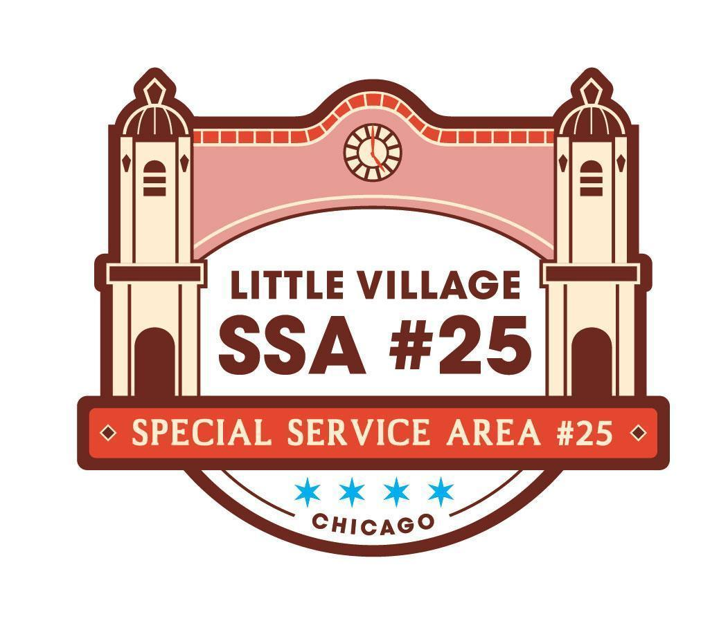

SSA #25 Special Commission Meeting
August 18, 2026
LV Chamber of Commerce Office
Antojitos Pozoleria, 2459 S Homan Ave Chicago, IL 60623
Meeting Minutes

9:00AM
- Welcome and Call Meeting to Order at 9:06 am
- SSA #25 Commissioner Roll Call
  - Commissioners Present: Elena Duran, Hugo Avila, Claudia Rodriguez, Ric Porrez, Mike Moreno Jr., Hugo Avila
  - Staff Present: Jennifer Aguilar, Veronica Pena, Alfredo Palafox, Paola Rodriguez
  - Public Present: Evelyn P., Carlos S.
- Approval of Agenda
  - Motion: Commissioner Duran moved to approve, Commissioner Moreno Jr. seconded, all approved
- Public Input (review guidelines for public input below)
  - Alfredo who is our outreach specialist has connected with both Evelyn and Carlos the owners of Alborada and has shared a little bit about the SSA #25. Both Evelyn and Carlos have shared their interest in becoming SSA #25 Commissioners and have been invited here today to share a little bit about themselves
- SSA #25 July 2026 Meeting Minutes pg 1-4
  - Motion: Hugo Avila moved to approve, Commissioner Porrez seconded, all approved
- SSA #25 July 2026 Financial Reports pg 5-10
  - As of July 2026 the total collected property tax revenue is $337,541.69 and from that $128,067.89 is from the collection of the 2024 property taxes, and $209,273.39 is from the 2025 property taxes.
  - As of July 2026 a total of $185,824.44 has been expensed
  - The largest expenses are landscaping at $49,949.00 and sidewalk maintenance at $39,266.68
  - Current cash flow is $323,232.71
  - Motion: Commissioner Moreno Jr. moved to approve, Commissioner Duran seconded, all approved
- SSA #25 Payment Disbursement pg 11
  - The check written for High Psi LTD- the ssa needs to a letter of donation for non profit for the power washer
  - Motion: Commissioner Avila, motioned to approve, Commissioner Porrez seconded, all approved

NEW BUSINESS:
- RFP for Branded Video pg 12-13
  - The commissioners want the proposals to be submitted by Sept 30, 2026 in order to try to get the film by spring 2027
  - New Items to be filmed are: Trolley, Villarte, potential interviews, Manuel Perez Plaza, The arch, The history of la villita with a timeline,
  - Commissioner Dural wants the arch highlighted
  - Commissioner Moreno Jr. has pictures he can provide for the timeline aspect of the video.
- QiPu Application for Facade Rebate ACTION ITEM pg 14-27
  - QiPu is a tax and accounting services business that is located at 4037 W 26th Street that has served the community since 2011. Wendy Saltos is the Co-owner along with Marlene Fernandez which have previously been awarded the Neighborhood Opportunity Fund grant allowing them to work on the first phase of the renovation of their windows, facade, and roofing. The second phase of renovation is to add a mural onto the second floor exterior wall of the building. Adding a hand-painted mural celebrating hispanic heritage through traditional imagery and colors designed and painted by a local artist, Mr Pintamuro.
  - MOTION: Commissioner Duran made a motion to approve, Commissioner Moreno Jr. seconded; all in favor
- 2026 Q2 Report ACTION ITEM pg 28-29
  - Every quarter the SSA #25 reports on both deliverables and Expenses
  - CUSTOMER ATTRACTION
    - 1.01 Website- our target was 1,000 visitors but received 14,704 visitors. It seemed like people were looking to see the available grants and programs
    - 1.02 Special Events- El dia el nino event was sponsored
    - 1.04 Social Media Outreach- target was 100, but had a total of 120,169 which made up a total of 120,075 opened e-blast and 94 social media posts
    - 1.05 Decorative Banners- expensed out $15,802 to instal 169 banners that pushed the Chicago Loves Local Champaign
    - 1.07 Printed Material- 200 flyers were posted in the effort to support the reduced plastic campaign.
  - PUBLIC WAY AESTHETICS
    - 2.01 Acid Etching Rebate Program target was 2 but received no applicants, even though this gets promoted on our e-blast and social media
    - 2.02 Landscaping- Expensed $24,975 to service a total of 166 planters
      - Commissioner Duran questioned on the update on whether the receptacles outside of the post office can be added to the rotation that landscape management does
        - Veronica will provide an update next meeting
    - 2.03 Facade Enhancement Program- there was 1 project and a total of $950 was expensed. This program is also promoted on our newsletter and social media
    - 2.08 Sidewalk maintenance- Expensed $27,211. The actual number of receptacles serviced were 4,062
    - 2.10 City Permits- to hang pole banners, permits are now required.
  - SUSTAINABILITY AND PUBLIC PLACES
    - 3.01 Garbage/ recycling Material Program- expensed $684 and collected a total of 1,354 bags of trash
  - ECONOMIC/ BUSINESS DEVELOPMENT
    - No expenses as the holiday trolley occurs during the fourth quarter.
  - PUBLIC HEALTH AND SAFETY PROGRAMS
    - 5.01 Public way surveillance cameras/maintenance- no applications for the rebate have been submitted, but are still promoting on our newsletter and outreach efforts
  - SSA MANAGEMENT
    - 6.02 SSA Audit- expensed $8,900
    - 6.03 Bookkeeping- $250
    - 6.04 Office Rent- $300
    - 6.05 Office Utilities- $225
    - 6.06 Office Supplies- $225
    - 6.07 office equipment lease.maintenance- $225
    - 6.08 Office printing- $225
    - 6.09 Postage- $225
    - 6.10 Commission Meeting Expense- 349
  - Motion: Commissioner Moreno Jr. made a motion to approve, Commissioner Avila seconded; all in favor
  - SIGNATURE NEEDED by chairperson

- 2026 Holiday Decorations ACTION ITEM pg 30-31
  - Veronica stated the billing information ont he inoviice will be changes into the ssa’s information instead of the chambers
  - Commissioner Avila motions to approves, Commissioner Moreno Jr. seconded, all approved

OLD BUSINESS:
- Next Commission Meeting
  - September 22nd , 2026
  - Little Village Chamber of Commerce 3610 w 26th st 2nd flr 60623

Guidelines for Public Input:
• The goal of public input is to ensure that all voices of the community are heard on matters pertaining to the work of Little Village SSA #25. The commission is not required to provide immediate response to questions nor concerns presented.
• Public input will be available at the start of each SSA #25 meeting once SSA #25 Commisisoner roll call has been made
• The opportunity to speak during public input will be available for all those in attendance;
however, speaking time may be limited depending on the number of attendees wishing to speak.
The Commission will aim to limit this portion of the meeting to no more than 15 minutes.
• The public forum portion of SSA #25 commission meetings, as with all portions of the meeting, will proceed according to Robert’s Rules of Order, most importantly:
-No attendee may speak twice until everyone else wishing to speak has spoken once.
-All remarks must be directed to the Chair.
-Remarks must be courteous in language and deportment avoiding all personal remarks and never alluding to others by name or to motives.
-One person may speak at a time, if not the presiding officer can call them out of order

