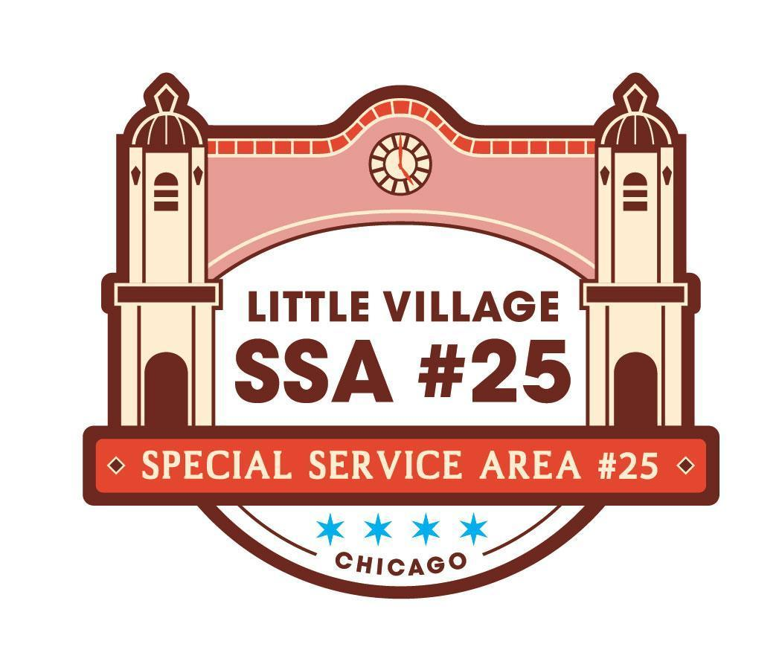

SSA #25 Special Commission Meeting
August 18, 2026
LV Chamber of Commerce Office
Antojitos Pozoleria, 2459 S Homan Ave Chicago, IL 60623
AGENDA

9:00AM
- Welcome and Call Meeting to Order
- SSA #25 Commissioner Roll Call
- Approval of Agenda
- Public Input (review guidelines for public input below)
- SSA #25 July 2026 Meeting Minutes pg 1-4
- SSA #25 July 2026 Financial Reports pg 5-10
  - Update on line Item in AR
- SSA #25 Payment Disbursement pg 11

NEW BUSINESS:
- RFP for Branded pg 12-13
- QiPu Application for Facade Rebate ACTION ITEM pg 14-27
- 2026 Q2 Worksheet ACTION ITEM pg 28-29
- 2026 Trolley ACTION ITEM pg 30-31

OLD BUSINESS:
- Next Commission Meeting
  - September 22nd , 2026
  - Don Pepe 3616 W 26th Street

Guidelines for Public Input:
• The goal of public input is to ensure that all voices of the community are heard on matters pertaining to the work of Little Village SSA #25. The commission is not required to provide immediate response to questions nor concerns presented.
• Public input will be available at the start of each SSA #25 meeting once SSA #25 Commisisoner roll call has been made
• The opportunity to speak during public input will be available for all those in attendance;
however, speaking time may be limited depending on the number of attendees wishing to speak.
The Commission will aim to limit this portion of the meeting to no more than 15 minutes.
• The public forum portion of SSA #25 commission meetings, as with all portions of the meeting, will proceed according to Robert’s Rules of Order, most importantly:
-No attendee may speak twice until everyone else wishing to speak has spoken once.
-All remarks must be directed to the Chair.
-Remarks must be courteous in language and deportment avoiding all personal remarks and never alluding to others by name or to motives.
-One person may speak at a time, if not the presiding officer can call them out of order

